21

Credit Card Fraud Detection Using Machine Learning

Project Id: AIML-12

Name : Riddhima Sharma(Team Leader)
Class Roll Number:21
University Roll Number : 2028474
Section and Group: U(G1)

Name : Disha Tahiliani
Class Roll Number: 11
University Roll Number : 2028413
Section and Group: U(G1)

Name : Aditya Rawal
Class Roll Number: 5
University Roll Number : 2028383
Section and Group: U(G1)

- Problem Description 3
- Architecture 4
- Models model 5-6
- Evaluation metrics used 7
- Preliminary Results and Visualizations 8-9
- References 10

- Problem Description
The exponential growth of digital transactions, online banking, and e-commerce platforms has significantly increased the risk of credit card fraud. Fraudulent activities result in billions of dollars in losses annually and pose serious threats to financial institutions and customers.
A major challenge in fraud detection is the extreme class imbalance present in datasets. In real-world datasets, fraudulent transactions account for less than 0.2% of total transactions. This makes traditional machine learning models ineffective, as they tend to bias toward the majority class.
The objective of this project is to develop a robust machine learning-based fraud detection system that:
Accurately classifies transactions as fraudulent or legitimate
Handles imbalanced data efficiently
Minimizes false positives and false negatives
Provides reliable predictions in real-time scenarios
The system primarily uses the K-Nearest Neighbors (KNN) algorithm along with proper preprocessing and evaluation techniques.

- Architecture

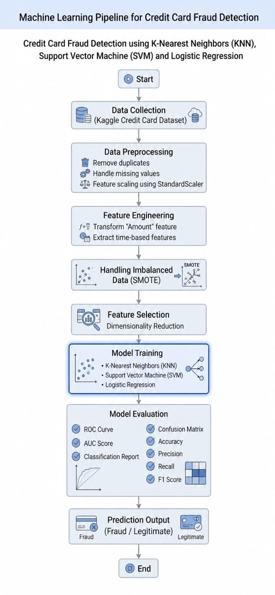

Fig.1 Sample flow diagram.

3.Models Used(Applied/ Planned) Give a brief introduction of the models used

In this project, multiple machine learning models are studied and analyzed for detecting fraudulent transactions. The following three models are considered:

1. K-Nearest Neighbors (KNN)
KNN is a supervised learning algorithm used for classification. It works based on similarity between data points.
Working:
Select value of K
Calculate distance between data points using Euclidean distance
Select K nearest neighbors
Assign class based on majority voting
Advantages:
Simple and easy to implement
No training phase (lazy learner)
Effective for small datasets
Disadvantages:
Slow for large datasets
Sensitive to noise and irrelevant features
Requires proper feature scaling

2. Logistic Regression
Logistic Regression is a statistical classification algorithm used for binary classification problems.
It predicts the probability that a given input belongs to a certain class using the sigmoid function.
Formula:
Working:
Takes weighted sum of input features
Applies sigmoid function
Outputs probability between 0 and 1
Classifies based on threshold (0.5)
Advantages:
Fast and efficient
Works well for linearly separable data
Easy to interpret
Disadvantages:
Cannot handle complex non-linear relationships
Sensitive to multicollinearity

3. Support Vector Machine (SVM)
SVM is a powerful supervised learning algorithm used for classification and regression.
It finds the optimal hyperplane that separates different classes with maximum margin.
Working:
Maps data into high-dimensional space
Finds optimal boundary (hyperplane)
Uses support vectors (critical points)
Advantages:
Works well for high-dimensional data
Effective in complex classification tasks
Robust to overfitting
Disadvantages:
Computationally expensive
Difficult to tune parameters
Less effective for very large datasets

- Evaluation metrics used

Due to class imbalance, multiple evaluation metrics are used:

Accuracy – Overall correctness
Precision – Reduces false fraud detection
Recall – Detects actual fraud cases
F1 Score – Balance between precision & recall
Confusion Matrix – Detailed prediction analysis
Auc score- measures binary classifiers ability to distinguish between classes
Roc curve- is a graph visualization binary classification model performance across all threshold plotting the true positive rate versus false positive rate
Classification report- evaluation metric that displays precision recall f1 score and support for each class in a classification model

5. Preliminary Results and Visualizations

The following visualizations were generated:

Correlation heatmap
Class imbalance distribution graph
Feature importance visualization
Observations:
Strong correlations exist between certain features
Fraud class is significantly underrepresented
Visualization helps in understanding patterns

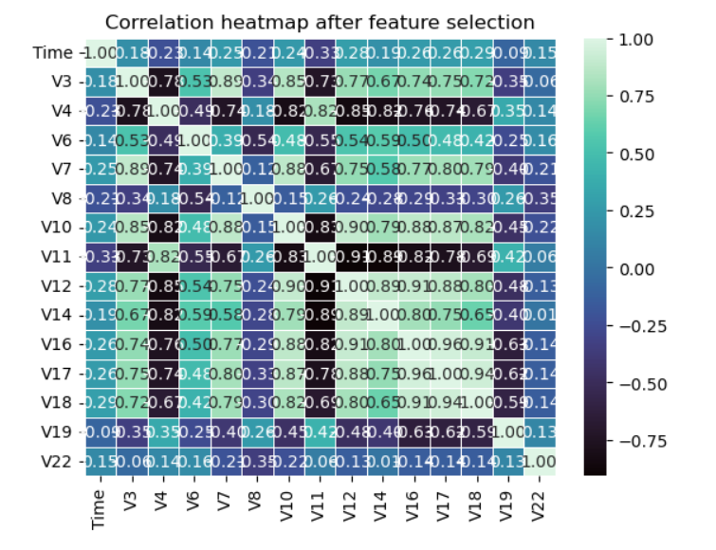

Fig.2 Heatmap showing corelation.

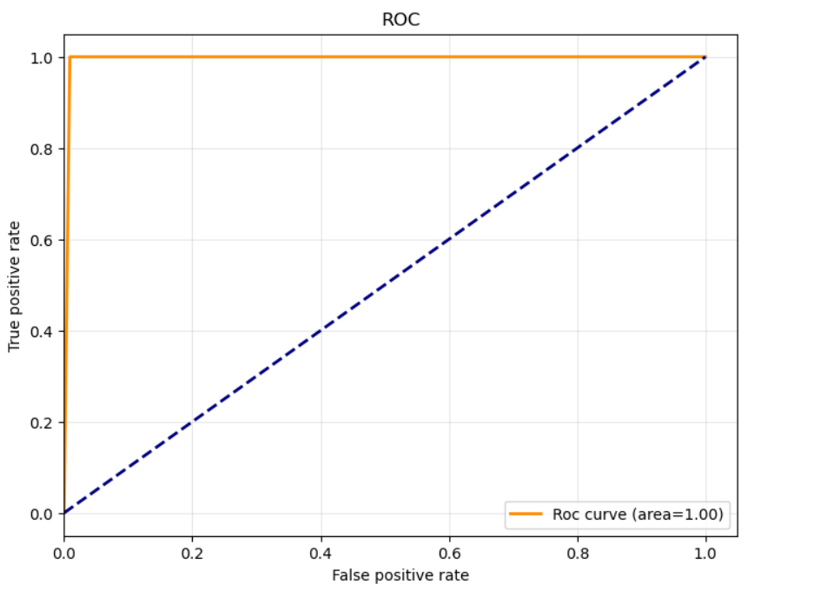
Fig3. Roc curve of knn
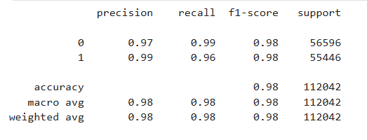
Fig4. Logistic regression

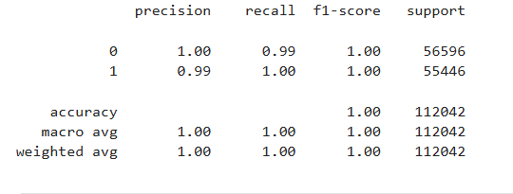

Fig5. KNN

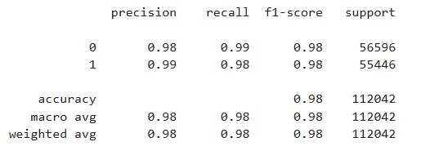

Fig6. SVM

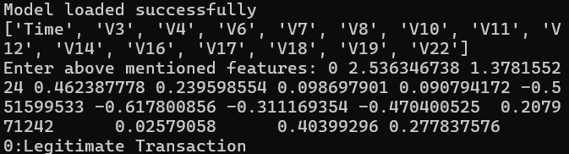

Fig 6.1

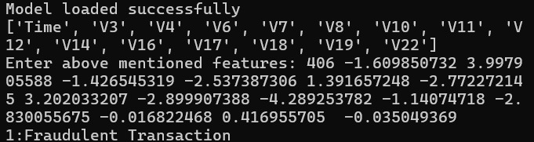

Fig 6.2

6. References:
Books:
- Let Us Python – Yashavant Kanetkar

Online Resources:
- Kaggle Dataset
- Scikit-learn Documentation
- GeeksforGeeks

